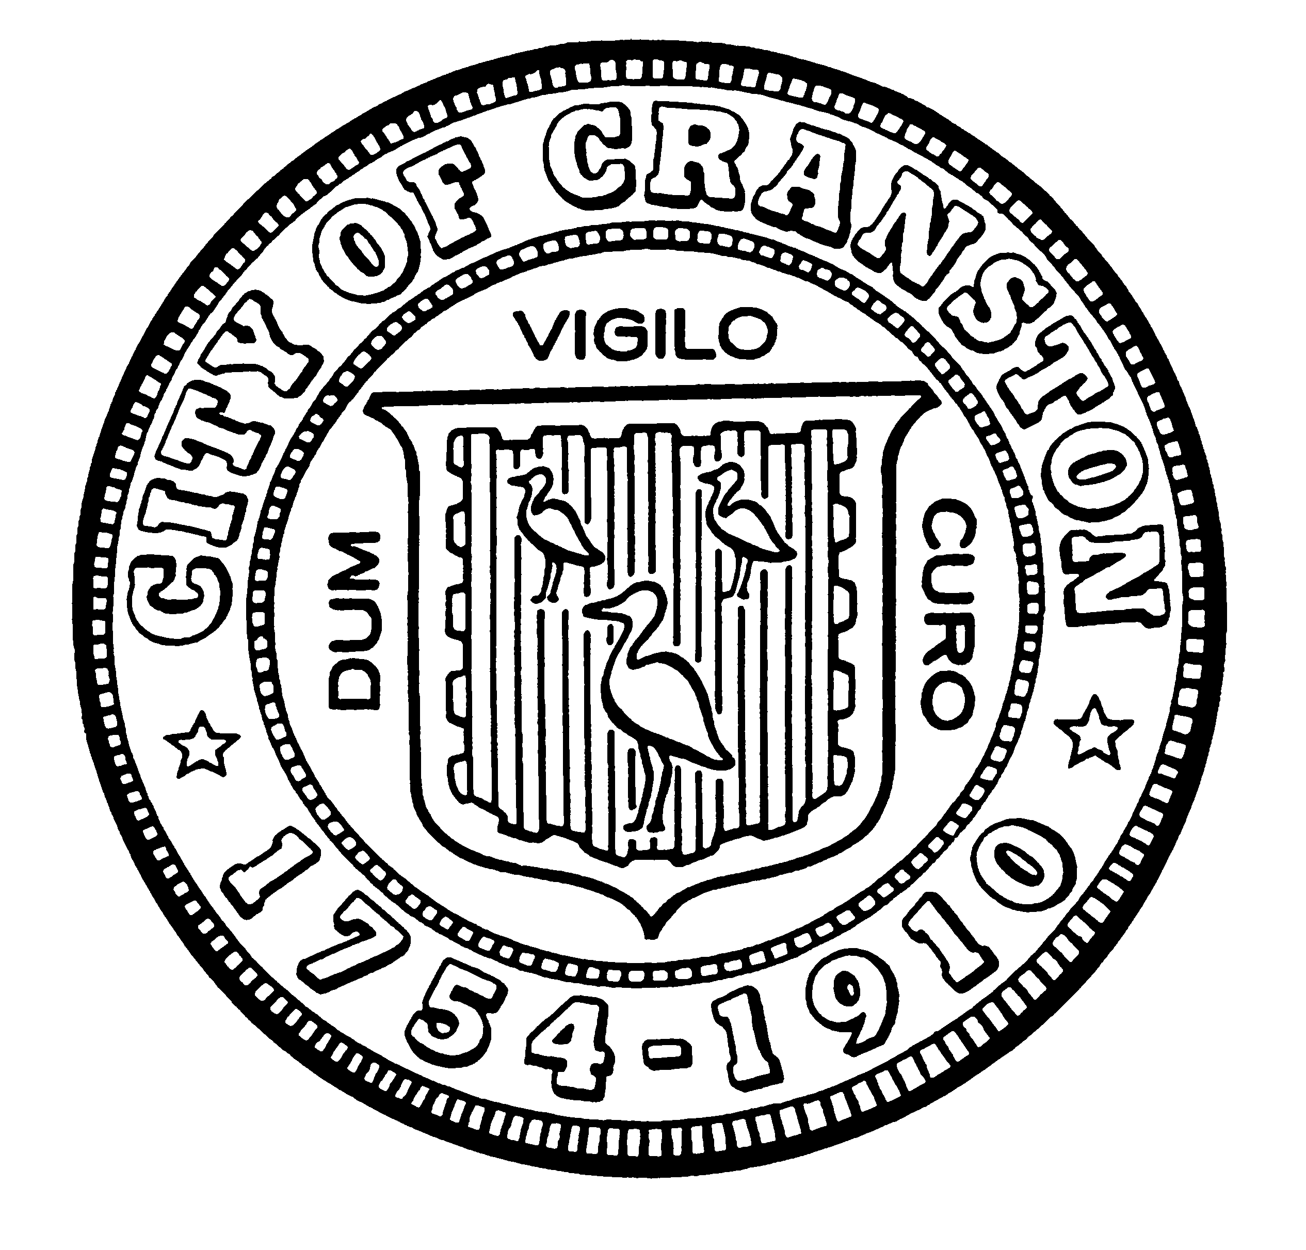

NOTICE OF JOINT PUBLIC WORKSHOP

COMPREHENSIVE PLAN 10-YEAR UPDATE

Cranston City Plan Commission
&
Cranston City Council

Tuesday, February 25th, 2020 - 6:30 P.M.

Cranston City Hall – Council Chamber

The Cranston City Plan Commission and the Cranston City Council is hosting a joint public workshop to kick off the 10-year update of the Cranston Comprehensive Plan. The purpose of the meeting is to begin the public discussions on the goals and aspirations of the City that help formulate the policies and objectives in the plan.

Throughout the remainder of 2020, the City Plan Commission intends to hold a series of six community meetings in various locations across the City. The information received during these forums will help guide the City moving forward.

This kick off meeting will also set the expectations of staff, the commission, the council and the community during the public engagement phase of the Comprehensive Plan rewrite. There will also be a discussion on the preferred format that works best for the public, as well as various methods to encourage robust community participation.

Light refreshments will be provided.

Individuals requesting interpreter services for the hearing impaired should contact the Planning Department at 461-1000 ext. 3136, seventy-two (72) hours prior to the meeting date.

Michael E. Smith Michael Farina
Plan Commission Chair City Council President

